KARASAR KENNELS

SHOW/BREEDING POTENTIAL PUPPY SALES CONTRACT

This agreement is entered into this ______________________________ for Whippet puppy between ________________________________________________________________________________________________
(Buyer) and Kerrie Kuper (Seller).This puppy is being bought on co-ownership with Kerrie Kuper. Buyer agrees to lease bitch to Kerrie Kuper for no less than ONE litter consisting of TWO live puppies, terms to be agreed to later.

The puppy being purchased is Karasar's____________ AKC# HP__________________ from litter born________ Sire is Ch Karasar's ____________and Dam is Ch _________________ Puppy # ______________
The price of this puppy is $_____________ Buyer received Health Certificate.

This puppy is guaranteed against disqualifying faults as defined by the AKC standard for the Whippet and hereditary defects (specifically eyes, heart, hips) which would render him/her to be of unsound breeding quality until 1 year of age.

This puppy has been wormed and inoculated on a regular schedule and is found to be free of illness upon leaving our premises. Please continue this puppy’s vaccination schedule with your veterinarian. It is not recommended to expose your puppy to public places where other dogs are allowed to run until it has completed the vaccination regimen. The incubation period for most contagious diseases is 7-10 days. Purchaser has 2 business days, after receiving the puppy, to bring the puppy to his/her own veterinarian for examination, pursuant to the paragraph below.

It is the consumers right, pursuant to section 828.29, Florida Statues, to receive a certificate of veterinary inspection with each dog or cat purchased from a pet dealer. Such certificate shall list all vaccines and deworming medications administered to the animal and shall state that the animal has been examined by a Florida licensed veterinarian who certifies that, to the best of his knowledge, the animal was found healthy at the time of veterinary examination. In the event that the consumer purchases the animal and finds it to have been unfit for purchase as provided in section 828.29, Florida Statues, the consumer must notify the pet dealer within 2 business days of the veterinarians’ determination that the animal was unfit. The consumer has the right to retain, return or exchange the animal and receive reimbursement for certain related veterinary services rendered to the animal, subject to the right of the dealer to have the animal examined by another veterinarian.

It is understood that puppies occasionally will be diagnosed with intestinal parasites or other protozoan/bacterial type disorders (i.e. coccidiosis or giardia) after leaving our premises. All efforts have been made to prevent and or treat infection of these puppies, but since they are allowed to run and play outside where birds, rabbits and other wild animal roam, sometimes puppies pick up these things that cannot be for seen. For this reason, if this puppy is diagnosed by your veterinarian with an intestinal parasite/condition within 48 hours of purchase, Kerrie Kuper agrees to reimburse the purchaser for the cost of medication to remedy the condition, not to exceed $25.00 total.

If a replacement is warranted due to illness, hereditary defect, or disqualifying fault as defined in the previous clauses, it will be in the form of another puppy of equal quality from a future breeding of Karasar Kennels, NO REFUNDS.
Original puppy MUST be returned to Kerrie Kuper, along with signed over AKC papers before a replacement is offered. All expenses associated with the care, feeding, and showing of this dog are the responsibility of the buyer. The dog will not be bred without the written permission of Kerrie Kuper.

It is expected that this dog be housed in sanitary conditions, free from urine, feces, and parasites (both internal and external), and that any crates and kennel runs Are of sufficient size for this dog to comfortably stand up, turn around, and lay down without touching the sides and top of the enclosure. In addition, this dog will be fed a quality commercial food recommended and or approved by the seller throughout its first year of life and receive sufficient exercise to develop proper muscle tone.

All contracts/agreements on this dog will expressly state that no resulting puppies from any mating will be sold to wholesale dog brokers, resellers, or puppy mill operations of any kind, and that puppies deemed pet quality from said matings will be placed with limited registration spay/neuter contracts. At no time will this bitch be bred to a stud that knowingly possess hereditary defects or disqualifying faults as defined by the AKC standard for the Whippet. This dog will NOT be spayed without the written permission of Kerrie Kuper. IF dog is spayed without the written permission of Kerrie Kuper, buyer will reimburse Kerrie Kuper $5000.00.

Ms. Kuper retains the right of first refusal if the buyer is unable to keep this dog for any reason. The buyer agrees to notify Ms. Kuper via certified mail of his/her intention to place said dog, and agrees to offer her/him back to Ms. Kuper, along with signed over AKC papers to full ownership to Ms. Kuper. Buyer then releases all future claims to the dog. Buyer is responsible for any and all expenses that may be associated with returning the dog to Ms. Kuper. In the even that Ms. Kuper cannot take the dog back, she agrees to sign off her co ownership to the buyer and relinquishes any interest in the dog.

In the event that the terms of this contract are not complied with, the seller is entitled to $5000.00 in damages and return of the dog along with signed over AKC papers, plus any legal fees and costs associated with the enforcement of this contract.

I have read and understand all the clauses in this agreement.

SIGNED:________________________________________ DATED:____________________________
Buyer

SIGNED:_________________________________________ DATED:____________________________

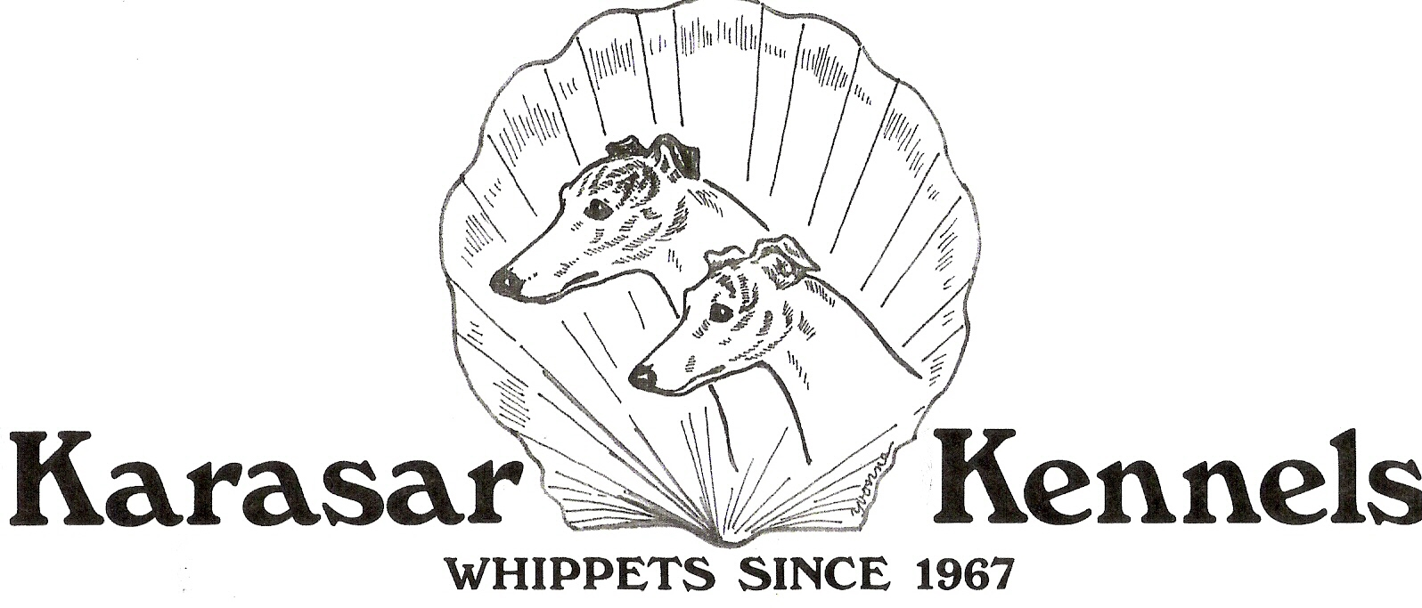
Seller

Kerrie Kuper kerriekuper@hotmail.com
Neil Barthelette
5580 4th Street North, St Petersburg, FL 33703

